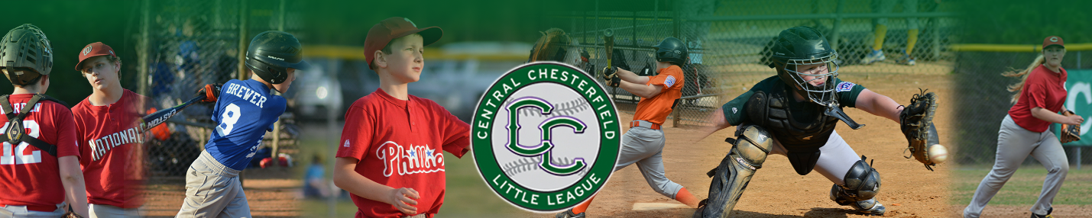

www.ccllbaseball.com
2026 Sponsorship Information

Central Chesterfield Little League (CCLL) is a nonprofit youth sports organization serving families throughout Chesterfield, VA, and the surrounding communities. Each spring and fall season, several hundred players and their families participate in our baseball programs. From March through October, games and practices are held at our four local fields and are attended by family members, friends, and community leaders from Chesterfield, Colonial Heights, Petersburg, and Fort Lee.
Community sponsorships play a vital role in making our league possible. Like many nonprofit youth sports organizations, CCLL operates largely through the dedication of volunteers and the generous support of local businesses. Sponsorships help provide essential equipment for our players, maintain our fields, cover operational expenses, and—most importantly—keep registration fees affordable for families in our community.
Central Chesterfield Little League offers a variety of sponsorship opportunities to fit different levels of involvement. Packages range from $500 to $1,500, with additional opportunities available for major sponsors. Sponsorship benefits include professionally produced advertising banners displayed at our fields (provided by CCLL), company name and logo placement on our website, recognition during Opening Day ceremonies, and promotion through our social media platforms. We are also happy to customize a sponsorship package that aligns with your organization’s goals and capacity. Additionally, we welcome donated items for use in raffles or auctions at our fundraising events.

Sponsorship Opportunities

Central Chesterfield Little League offers several sponsorship levels to fit a variety of budgets and partnership goals:
Grand Slam Sponsor – $1,500
• Company name and logo displayed on two 4’ x 8’ banners, including one banner placed in a premier, high-visibility location at our fields
• Company name and logo featured on the league website
• Sponsorship recognition through CCLL social media channels
• Opportunity to host a booth at both Opening Day and Championship Day events
Home Run Sponsor – $1,000
• Company name and logo displayed on two 4’ x 8’ field banners
• Company name and logo featured on the league website
• Sponsorship recognition through CCLL social media channels
• Opportunity to host a booth at both Opening Day and Championship Day events
Triple Sponsor – $500
• Company name and logo displayed on one 4’ x 8’ field banner
• Company name and logo featured on the league website
• Sponsorship recognition through CCLL social media channels
Single Sponsor – Contribution of Any Amount
• Company name and logo listed on the CCLL website (ccllbaseball.com)
All sponsorship banners are provided by Central Chesterfield Little League at no cost to your organization. We simply ask that you supply your company name, logo, and phone number so we can produce the banners on your behalf. Central Chesterfield Little League is a nonprofit charitable organization, and all sponsorship contributions are tax-deductible. An invoice and the league’s tax identification number will be provided for all sponsorship levels.
On behalf of our players, families, and volunteers, the Central Chesterfield Little League Board of Directors sincerely thanks you for your consideration and support. We would be honored to partner with you through a sponsorship opportunity that not only fits your budget, but also reflects your heart for investing in the children and families of our community.

If you are interested in a Central Chesterfield Little League Sponsorship, CCLL has two ways to sign up and become a league sponsor:
Online Registration Form 2026 Sponsorship Sign Up
Print and Mail Application

The Online Registration Form provides an easy way to fill out the form on the internet and then pay by credit card, if you choose, or you can mail in a check. We use the same vendor to accept the application and payment that we have been using for several year for player registrations. The Print and Mail Application is the same application that has been used in the past and it requires you to print it, fill it out, and mail it in with your check. You only need to pick one method or the other, not both, and fill it out to become a Sponsor.

Please contact Joe Mayes at (804) 931-7225 or sponosorships@ccllbaseball.com with questions.

CCLL Sponsorship Incentive Program
Central Chesterfield Little League (CCLL) is a nonprofit organization that depends heavily on community volunteers and local support. While volunteerism is essential, there are significant costs associated with operating the league, including uniforms, equipment, umpires, and field maintenance. Sponsorships play a key role in helping offset these expenses and keeping participation affordable for our families.
To encourage league members to help recruit sponsors, CCLL offers a Sponsorship Incentive Program. This program rewards families who connect the league with new sponsors by providing registration discounts or refunds based on the sponsorship level secured.
Sponsors may sign up online through the main CCLL website under “2024 Sponsorship Sign Up – Spring 2024.” We encourage all league members to share information about this program so more families can benefit from this opportunity.

Incentive Program Details
- Triple Sponsor ($500): $50 registration discount or refund for one player
- Home Run Sponsor ($1,000 or more): Full waiver or refund of one player’s registration fee

Program Guidelines
- The sponsor must be directly referred to the league’s Sponsorship Coordinator.
- Referrals must be made by the league member via email or phone to the Sponsorship Coordinator.
- The Sponsorship Coordinator will work directly with potential sponsors to finalize sponsorship details.
- CCLL must receive full payment from the sponsor before any discount or refund is applied.
- League members who own or directly manage a business are eligible to participate in this program.
- All sponsorships are subject to approval by the CCLL Board of Directors.

